­­

1. Which of the following App Service plans supports only function apps?
   * Dedicated
   * Isolated
   * **Consumption**
     1. That's correct. The consumption tier is only available to function apps. It scales the functions dynamically depending on workload.
2. Which of the following App Service plans supports all of the app types available in App Service?
   * Dedicated
   * **Isolated**
   * Consumption
3. Which of the following networking features of App Service can be used to control **outbound** network traffic?
   * App-assigned address
   * **Hybrid Connections**
   * Service endpoints
4. Which of the following networking features of App Service can be used to control inbound network traffic?
   * App-assigned address
   * Hybrid Connections
   * **Service endpoints**
5. In which of the app configuration settings categories below would you set the language and SDK version?

* Application settings
* Path mappings
* **General settings**
  + That's correct. This category is used to configure stack, platform, debugging, and incoming client certificate settings.

1. In which of the app configuration settings categories below would you used to configure stack, platform, debugging, and incoming client certificate settings?

* Application settings
* Path mappings
* **General settings**

1. Which of the following types of application logging is supported on the Linux platform?

* Web server logging
* Failed request tracing
* **Deployment logging**

1. Which of the following choices correctly lists the two parts of a feature flag?
   * Name, App Settings
   * **Name, one or more filters**
   * Feature manager, one or more filters
2. A feature manager is an application package that handles the lifecycle of all the feature flags in an application
   * **feature manager**
   * Name
   * App Settings
   * One or more filters
3. Which of these statements best describes autoscaling?

* Autoscaling requires an administrator to actively monitor the workload on a system.
* **Autoscaling is a scale out/scale in solution.**
* Scaling up/scale down provides better availability than autoscaling.

1. Which of these scenarios is a suitable candidate for autoscaling?

* **The number of users requiring access to an application varies according to a regular schedule. For example, more users use the system on a Friday than other days of the week.**
* The system is subject to a sudden influx of requests that grinds your system to a halt.
* Your organization is running a promotion and expects to see increased traffic to their web site for the next couple of weeks.

1. There are multiple rules in an autoscale profile. Which of the following scale operations will run if all of the rule conditions are met?

* scale-out
* **scale-in**
* scale-out/in

1. There are multiple rules in an autoscale profile. Which of the following scale operations will run if any of the rule conditions are met?

* **scale-out**
* scale-in
* scale-out/in

1. By default, all client requests to the app's production URL (http://<app_name>.azurewebsites.net) are routed to the production slot. One can automatically route a portion of the traffic to another slot. What is the default routing rule applied to new deployment slots?

* **0%**
* 10%
* 20%

1. Some configuration elements follow the content across a swap (not slot specific), whereas other configuration elements stay in the same slot after a swap (slot specific). Which of the settings below are swapped?

* Publishing endpoints
* **WebJobs content**
* WebJobs schedulers

1. Some configuration elements follow the content across a swap (not slot specific), whereas other configuration elements stay in the same slot after a swap (slot specific). Which of the settings below are not swapped?

* Publishing endpoints
* WebJobs content
* **WebJobs schedulers**

1. Which of the following Azure Functions hosting plans is best when predictive scaling and costs are required?

* Functions Premium Plan
* **App service plan**
* Consumption plan

1. An organization wants to implement a serverless workflow to solve a business problem. One of the requirements is the solution needs to use a **designer-first (declarative)** development model. Which of the choices below meets the requirements?

* Azure Functions
* **Azure Logic Apps**
* WebJobs

1. An organization wants to implement a serverless workflow to solve a business problem. One of the requirements is the solution needs to use a **code-first (imperative)** development model. Which of the choices below meets the requirements?

* Azure Functions
* Azure Logic Apps
* **WebJobs**

1. Which of the following is required for a function to run?

* Binding
* **Trigger**
* Both triggers and bindings

1. Which of connects to function

* **Binding**
* Trigger
* Both triggers and bindings

1. Which of the following supports both the in and out direction settings?

* **Bindings**
* Trigger
* Connection value

1. Which of the following supports only the in-direction settings?

* Bindings
* **Trigger**
* Connection value

1. Which is used to connect your function to other Azure services.

* Bindings
* Trigger
* **Connection value**

1. Which of the following durable function types is used to read and update small pieces of state?
   * Orchestrator
   * Activity
   * **Entity**
2. Which re the basic unit of work in a durable function orchestration and do not manage state.

* Orchestrator
* **Activity**
* Entity

1. Which one describe how actions are executed and the order in which actions are executed.
   * **Orchestrator**
   * Activity
   * Entity
2. Which application pattern would you use for a durable function that is polling a resource until a specific condition is met?
   * Function chaining
   * Fan out/fan in
   * **Monitor**
3. Which application pattern would you use for a sequence of functions executes in a specific order.?
   * **Function chaining**
   * Fan out/fan in
   * Monitor
4. Which application pattern would you execute multiple functions in parallel and then wait for all functions to finish.?
   * Function chaining
   * **Fan out/fan in**
   * Monitor
5. Which blobs are ideal for scenarios such as logging data from virtual machines.

* Block Blobs
* **Append Blobs**
* Page Blobs

1. Which blobs store random access files

* Block Blobs
* Append Blobs
* **Page Blobs**

1. Which blobs store virtual hard drive (VHD) files and serve as disks for Azure virtual machines.

* Block Blobs
* Append Blobs
* **Page Blobs**

1. Which of the following types of blobs are used to store virtual hard drive files?
   * Block blobs
   * Append blobs
   * **Page blobs**
2. Which of the following types of blobs are made up of blocks of data that can be managed individually.?
   * **Block blobs**
   * Append blobs
   * Page blobs
3. Which of the following types of storage accounts is recommended for most scenarios using Azure Storage?

* **General-purpose v2**
  + That's correct. This supports blobs, files, queues, and tables. It's recommended for most scenarios using Azure Storage.
* General-purpose v1
* FileStorage

1. Azure Storage automatically encrypts your data when persisting it to the cloud. – **True**
2. Azure Storage encryption is similar to BitLocker encryption on Windows. – **True**
3. Azure Storage encryption is enabled for all new and existing storage accounts and cannot be disabled. – **True**
4. There is no additional cost for Azure Storage encryption. – **True**
5. Encryption does not affect Azure Storage performance. – **True**
6. Azure Storage always stores multiple copies of your data so that it is protected from planned and unplanned events. – **True**
7. Which are the Azure Storage options for how your data is replicated in the primary region.
   * **Locally redundant storage (LRS)**
   * **Zone-redundant storage (ZRS)**
   * Geo-redundant storage (GRS)
   * Geo-zone-redundant storage (GZRS)
8. Which are the Azure Storage redundancy options for how your data is replicated in the secondary region.
   * Locally redundant storage (LRS)
   * Zone-redundant storage (ZRS)
   * **Geo-redundant storage (GRS)**
   * **Geo-zone-redundant storage (GZRS)**
9. Which redundancy Option Copies your data synchronously three times within a single physical location in the primary region.
   * **Locally redundant storage (LRS)**
   * Zone-redundant storage (ZRS)
   * Geo-redundant storage (GRS)
   * Geo-zone-redundant storage (GZRS)
10. Which redundancy Option Copies your data synchronously across three Azure availability zones in the primary region.
    * Locally redundant storage (LRS)
    * **Zone-redundant storage (ZRS)**
    * Geo-redundant storage (GRS)
    * Geo-zone-redundant storage (GZRS)
11. Which redundancy Option Copies your data synchronously three times within a single physical location in the primary region using LRS.
    * Locally redundant storage (LRS)
    * Zone-redundant storage (ZRS)
    * **Geo-redundant storage (GRS)**
    * Geo-zone-redundant storage (GZRS)
12. Which redundancy Option Copies your data synchronously across three Azure availability zones in the primary region using ZRS.
    * Locally redundant storage (LRS)
    * Zone-redundant storage (ZRS)
    * Geo-redundant storage (GRS)
    * **Geo-zone-redundant storage (GZRS)**
13. The access tier can be set on a blob during or after upload. **– True**
14. Which access tiers can be set at the account level.
    * **Hot**
    * **Cool**
    * Archive
15. The archive access tier can only be set at the blob level.
    * Hot
    * Cool
    * **Archive**
16. Data in the ________ access tier is stored offline.
    * Hot
    * Cool
    * **Archive**
17. Which access tier is considered to be offline and can't be read or modified?

* Cool
* **Archive**
* Hot

1. Which access tier is considered to be offline and can be read or modified?
   * **Cool**
   * Archive
   * **Hot**
2. The hot and cool tiers support all redundancy options. **– True**
3. The archive tier supports only LRS, GRS, and RA-GRS. **– True**
4. Data storage limits are set at the account level and not per access tier. **– True**
5. General Purpose v1 accounts need to be upgraded to v2 before lifecycle policies are supported -true
6. Azure Blob storage lifecycle management offers a rich, rule-based policy for

* **General Purpose v2**
* **Blob storage accounts**

1. Which of the following storage account types supports lifecycle policies?

* General Purpose v1
* **General Purpose v2**
* FileStorage

1. Which of the following storage account types **does not supports lifecycle policies**?

* General Purpose v1
* General Purpose v2
* **FileStorage**

1. The **lifecycle management policy** lets you:
   * Azure Storage lifecycle management offers a rule-based policy that you can use to transition blob data to the appropriate access tiers or to expire data at the end of the data lifecycle.
   * For a base blob, you can choose to check one of the following conditions:
     1. The number of days since the blob was created.
     2. The number of days since the blob was last modified.
     3. The number of days since the blob was last accessed.

* Transition blobs to a cooler storage tier (hot to cool, hot to archive, or cool to archive) to optimize for performance and cost
* Delete blobs at the end of their lifecycles
* Define rules to be run once per day at the storage account level
* Apply rules to containers or a subset of blobs (using prefixes as filters)

1. Which rules are available to move aging data to cooler tiers.
   * **lifecycle management policy rules**
2. You can add, edit, or remove a policy by using any of the following methods:
   * **Azure portal**
   * **Azure PowerShell**
   * **Azure CLI**
   * **REST APIs**
3. Two options for rehydrating a blob that is stored in the archive tier:
   * **Copy an archived blob to an online tier**:
   * **Change a blob's access tier to an online tier**:
4. You can rehydrate an archived blob by copying it to a new blob in the hot or cool tier with the below operations
   * **Copy Blob**
   * **Copy Blob from URL.**
5. To rehydrating a blob from the archive tier to an online tier is to change the blob's tier by calling
   * **Set Blob Tier**.
6. You can rehydrate an archived blob to hot or cool by changing its tier using the ________ operation
   * Set Blob Tier operation.
7. The rehydration priority property returns either
   * Standard or High.
8. Changing a blob's tier doesn't affect its last modified time. **– True**

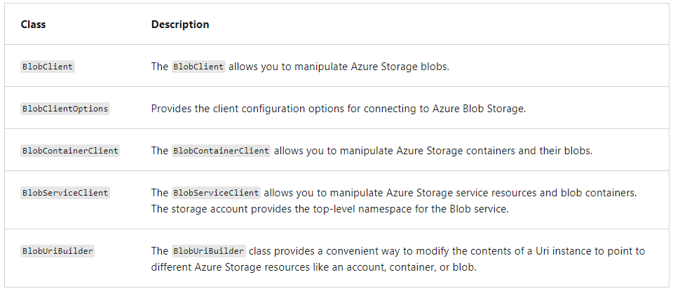

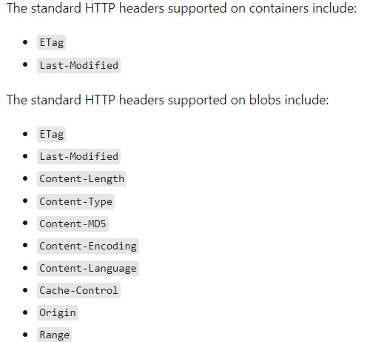

1. Which of the following standard HTTP headers are supported for both containers and blobs when setting properties by using REST?

* **Last-Modified**
  + That's correct. Last-Modified is supported on both containers and blobs.
* Content-Length
* Origin

1. Which of the following classes of the Azure Storage client library for .NET allows you to manipulate both Azure Storage containers and their blobs?

* BlobClient
* **BlobContainerClient**
  + That's correct. The BlobContainerClient can be used to manipulate both containers and blobs.
* BlobUriBuilder

1. Which is the fundamental unit of global distribution and high availability.
   * **Azure Cosmos DB account**
   * Azure Cosmos DB container
2. Which is the is the fundamental unit of scalability.
   * Azure Cosmos DB account
   * **Azure Cosmos DB container**
3. Which is the is the unit of scalability both for provisioned throughput and storage.
   * Azure Cosmos DB account
   * **Azure Cosmos DB container**
4. A _______ is a schema-agnostic container of items
   * **Container**
   * Item
   * Collection
5. Which of the following standard HTTP headers are supported for both containers and blobs when setting properties by using REST?

* **Last-Modified**
* Content-Length
* Origin

1. Which of the following standard HTTP headers are supported for only blobs when setting properties by using REST?

* Last-Modified
* Content-Length
* **Origin**

1. Which of the following two standard HTTP headers are supported for blobs when setting properties by using REST?

* Last-Modified
* **Content-Length**
* **Origin**

1. Which of the following classes of the Azure Storage client library for .NET allows you to manipulate only blobs?

* **BlobClient**
* BlobContainerClient
* BlobUriBuilder

1. Which of the following classes of the Azure Storage client library for .NET allows you to manipulate both Azure Storage containers and their blobs?

* BlobClient
* **BlobContainerClient**
* BlobUriBuilder

1. When setting up Azure Cosmos DB there are three account type options. Which of the account type options below is used to **specify the number of RUs for an application on a per-second basis**?

* **Provisioned throughput**
* Serverless
* Autoscale

1. When setting up Azure Cosmos DB there are three account type options. Which of the account type options **you don't have to provision any throughput when creating** resources in your Azure Cosmos DB account

* Provisioned throughput
* **Serverless**
* Autoscale

1. When setting up Azure Cosmos DB there are three account type options. Which of the account type options you can automatically and instantly scale the throughput (RU/s)

* Provisioned throughput
* Serverless
* **Autoscale**

1. Which of the following consistency levels below offers the greatest throughput?

* Strong
* Session
* **Eventual**

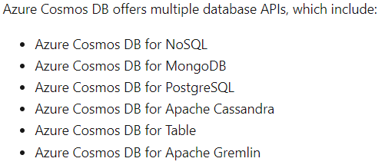

1. Azure Cosmos DB is a fully managed __________ database designed to provide low latency, elastic scalability of throughput, well-defined semantics for data consistency, and high availability.
   * **NoSQL**
   * MongoDB
   * PostgreSQL
   * Table
2. Which is the native for Azure Cosmos DB.
   * **NoSQL**
   * MongoDB
   * PostgreSQL
   * Table
3. The default consistency level configured on your account applies to all following under that account.
   * **Azure Cosmos DB databases**
   * **Containers**

|  |  |  |
| --- | --- | --- |
| **Database APIs** | **Stores Data in Format** | **Other points** |
| API for NoSQL | stores data in document format | * It offers the best end-to-end experience as we have full control over the interface, service, and the SDK client libraries. * Any new feature that is rolled out to Azure Cosmos DB is first available on API for NoSQL accounts. * NoSQL accounts provide support for querying items using the Structured Query Language (SQL) syntax. |
| API for MongoDB | stores data in a document structure, via BSON format. |  |
| API for PostgreSQL | stores data either on a single node, or distributed in a multi-node configuration. |  |
| API for Apache Cassandra | stores data in column-oriented schema. |  |
| API for Apache Gremlin | The Azure Cosmos DB API for Gremlin allows users to make graph queries and stores data as edges and vertices. |  |
| API for Table | stores data in key/value format. |  |

1. When setting up Azure Cosmos DB there are three account type options. Which of the account type options below is used to specify the number of RUs for an application on a per-second basis?
   * **Provisioned throughput**
     1. That's correct. In this mode, you provision the number of RUs for your application on a per-second basis in increments of 100 RUs per second.
   * Serverless
   * Autoscale
2. Which of the following consistency levels below offers the greatest throughput?
   * Strong
   * Session
   * **Eventual**
     1. That's correct. The eventual consistency level offers the greatest throughput at the cost of weaker consistency.
3. Which of the options below best describes the relationship between logical and physical partitions?
   * Logical partitions are collections of physical partitions.
   * **Physical partitions are collections of logical partitions**
     1. That's correct. One or more logical partitions are mapped to a single physical partition.
   * There's no relationship between physical and logical partitions.
4. Which of the below correctly lists the two components of a partition key?
   * Key path, synthetic key
   * **Key path, key value**
     1. That's correct. A partition key has two components: partition key path and the partition key value.
   * Key value, item ID
5. You can implement transactions on items within a container by using a.
   * **stored procedure**
6. All Azure Cosmos DB operations must complete within a limited amount of time. **– True**
7. All collection functions return a Boolean value that represents whether that operation will complete or not. **– True**
8. Azure Cosmos DB supports following triggers
   * **pre-triggers**
   * **post-triggers.**
9. Pre-triggers cannot have any input parameters. **– True**
10. When defining a stored procedure in the Azure portal input parameters are always sent as what type to the stored procedure?
    * **String**
      1. Correct. When defining a stored procedure in Azure portal, input parameters are always sent as a string to the stored procedure.
    * Integer
    * Boolean
11. Which of the following would one use to validate properties of an item being created?
    * **Pre**-**trigger**
      1. Correct. Pre-triggers can be used to conform data before it's added to the container.
    * Post-trigger
    * User-defined function
12. Azure virtual machines can be used in various ways
    * **Development and test**
    * **Applications in the cloud**
    * **Extended datacenter**
13. You can get a list of images in the marketplace by using the _______command.
    * **az vm image list**
14. Windows VMs have _________ which give your VM additional capabilities through post deployment configuration and automated tasks.
    * **Extensions**
15. These common tasks can be accomplished using extensions:
    * **Run custom scripts**
    * **Deploy and manage configurations**
    * **Collect diagnostics data**
16. Which VM extension helps you configure workloads on the VM by running your script when the VM is provisioned:
    * **Run custom scripts**
    * **Deploy and manage configurations**
    * Collect diagnostics data
17. Which VM extension helps you configure workloads on the VM by running your script when the VM is provisioned:
    * **Custom script Extension**
    * **PowerShell Desired State Configuration (DSC) Extension**
    * Azure Diagnostics Extension
18. Which VM extension helps you set up DSC on a VM to manage configurations and environments
    * **Custom script Extension**
    * **PowerShell Desired State Configuration (DSC) Extension**
    * Azure Diagnostics Extension
19. Which VM extension helps you configure the VM to collect diagnostics data that can be used to monitor the health of your application:
    * **Custom script Extension**
    * **PowerShell Desired State Configuration (DSC) Extension**
    * **Azure Diagnostics Extension**
20. An Availability Zone in an Azure region is a combination of a
    * fault domain and an update domain.
21. A __________is a logical group of underlying hardware that share a common power source and network switch, similar to a rack within an on-premises datacenter.

* **Fault domain**
* Update domain
* Availability zone
* Availability set

1. A __________ is a logical group of underlying hardware that can undergo maintenance or be rebooted at the same time.

* Fault domain
* **Update domain**
* Availability zone
* Availability set

1. As you create VMs within an availability set, the Azure platform automatically distributes your VMs across these fault domains. **– True**

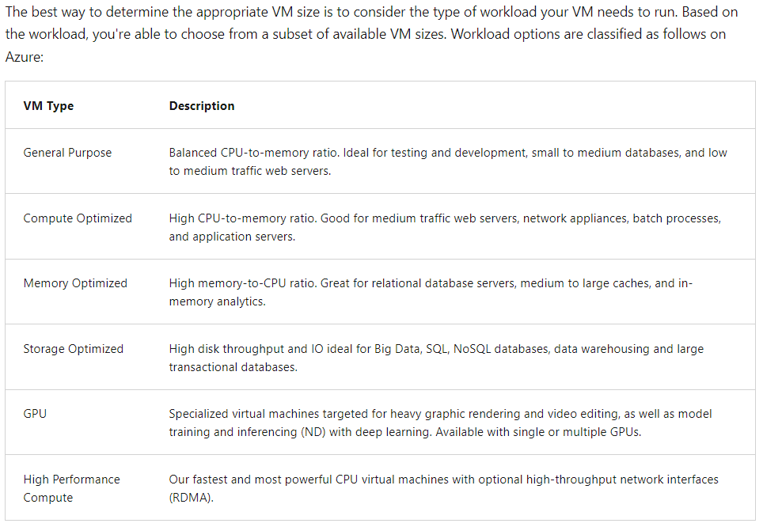

1. Which of the following Azure virtual machine types is most appropriate for testing and development?

* Compute optimized
* **General Purpose**
  + That's correct. This type has a balanced CPU-to-memory ratio, and is ideal for testing and development.
* Storage optimized

1. Which of the below represents a logical grouping of VMs that allows Azure to understand how your application is built to provide for redundancy and availability?

* Load balancer
* Availability zone
* **Availability set**
  + That's correct. An availability set is a logical grouping of VMs Reason.

1. _______________ allow you to create and deploy an entire Azure infrastructure declaratively.
   * **Azure Resource Manager templates**
   * Azure Resource Group
2. What are all can deploy using Azure Resource Manager templates
   * **Virtual Machines**
   * **Network Infrastructures**
   * **Storage Systems**
   * **Any other resources you may need**
3. When you deploy a template, Resource Manager converts the template into _________ operations.
   * **REST API**
   * CRUD
4. You can deploy a template using any of the following options:
   * Azure portal
   * Azure CLI
   * PowerShell
   * REST API
   * Button in GitHub repository
   * Azure Cloud Shell
5. _____________enable you to store a template as a resource type.
   * **Template specs**
6. When deploying your resources, you specify that the deployment is either an
   * incremental update (Default)
   * complete update.
7. In which mode Resource Manager **deletes** resources that exist in the resource group that aren't specified in the template.
   * **In complete mode**
   * In incremental mode
8. In which mode Resource Manager **leaves unchanged** resources that exist in the resource group but aren't specified in the template.
   * In complete mode
   * **In incremental mode**

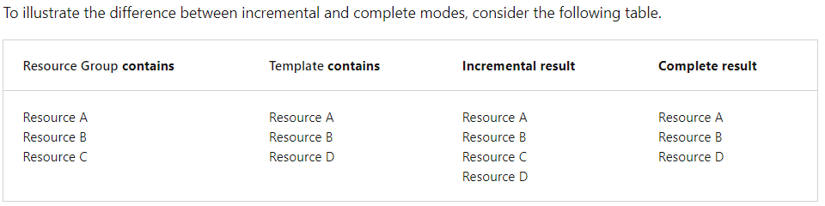

1. What purpose does the outputs section of an Azure Resource Manager template serve?
   * Specify the resources to deploy.
   * **Return values from the deployed resources**
     1. That's correct. The "outputs" section returns values from the resource(s) that were deployed.
   * Define values that are reused in your templates.
2. Which Azure Resource Manager template deployment mode deletes resources in a resource group that aren't specified in the template?
   * Incremental
   * **Complete**
     1. That's correct. Complete mode will delete resources not specified in an Azure Resource Manager template deployment.
   * Both incremental and complete delete resources

Monitoring App Performance

1. Which is the powerful data analysis platform in Azure Monitor to provide you with deep insights into your application's operations.
   * **Application Insights**
   * Container Insights
   * VM Insights
2. Which one enables you to diagnose errors without waiting for a user to report them.
   * **Application Insights**
   * Container Insights
   * VM Insights
3. Which one monitors the performance of container workloads that are deployed to managed Kubernetes clusters hosted on Azure Kubernetes Service (AKS) and Azure Container Instances.
   * Application Insights
   * **Container Insights**
   * VM Insights
4. Which one gives you performance visibility by collecting metrics from controllers, nodes, and containers that are available in Kubernetes through the Metrics API.
   * Application Insights
   * **Container Insights**
   * VM Insights
5. Which one analyzes the performance and health of your Windows and Linux VMs and identifies their different processes and interconnected dependencies on external processes.
   * Application Insights
   * Container Insights
   * **VM Insights**
6. Which one monitors your Azure virtual machines (VM) at scale.
   * Application Insights
   * Container Insights
   * **VM Insights**

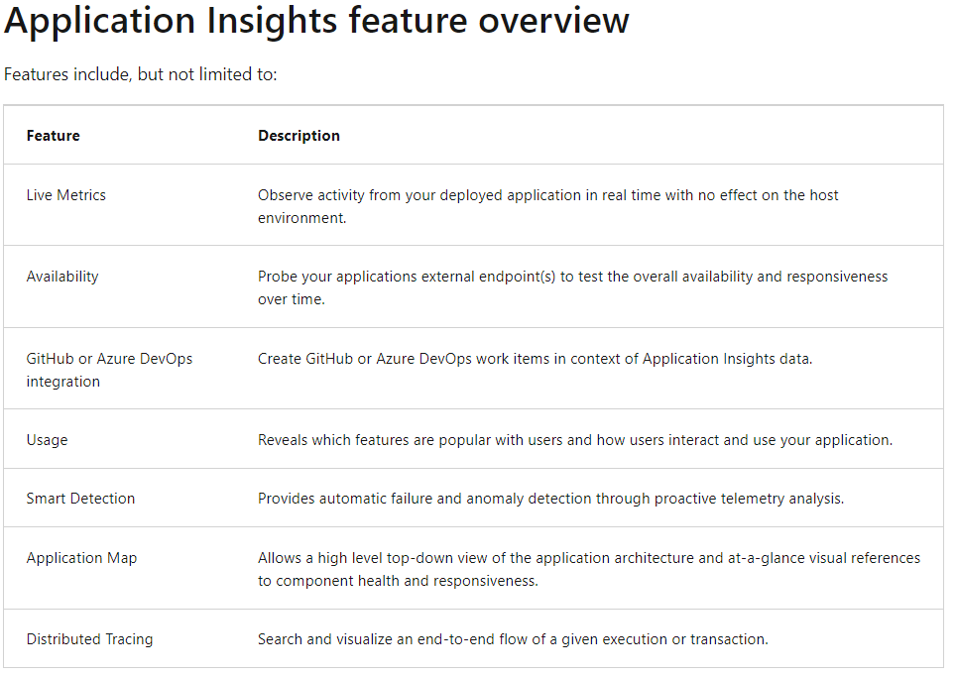

1. Application Insights is enabled through either
   * Auto-Instrumentation (agent)
   * by adding the Application Insights SDK to your application code.
2. Which of the availability test relies on the DNS infrastructure of the public internet to resolve the domain names of the tested endpoints.
   * **URL Ping Test (Classic)**
   * Standard Test (Preview)
   * Custom TrackAvailability test
3. Which of the availability test validate whether an endpoint is responding and measure performance associated with that response.
   * **URL Ping Test (Classic)**
   * Standard Test (Preview)
   * Custom TrackAvailability test
4. Which one improves the performance and scalability of an application that uses backend data stores heavily.
   * **Redis**
5. Which one able to process large volumes of application requests by keeping frequently accessed data in the server memory, which can be written to and read from quickly.
   * **Redis**
6. Which one brings a critical low-latency and high-throughput data storage solution to modern applications
   * **Redis**
7. Which tier has no service-level agreement (SLA) and is ideal for development/test and non-critical workloads
   * **Basic**
   * Standard
   * Premium
   * Enterprise
   * Enterprise Flash
8. offers higher throughput, lower latency, better availability, and more features
   * Basic
   * Standard
   * **Premium**
   * Enterprise
   * Enterprise Flash
9. Which tier suupports Redis modules including RediSearch, RedisBloom, and RedisTimeSeries
   * Basic
   * Standard
   * Premium
   * **Enterprise**
   * Enterprise Flash
10. Which offers developers a global solution for rapidly delivering high-bandwidth content to users by caching their content at strategically placed physical nodes across the world.
    * Content Delivery Network (CDN)
11. Which one accelerate dynamic content, which cannot be cached, by leveraging various network optimizations using CDN POPs.
    * Content Delivery Network (CDN)
12. Azure Content Delivery Network (CDN) includes four products:

* Azure CDN Standard from Microsoft
* Azure CDN Standard from Akamai
* Azure CDN Standard from Verizon
* Azure CDN Premium from Verizon

1. If you don't set a TTL (time to live) on a file, Azure CDN sets a default value. However, this default may be overridden if you have set up caching rules in Azure. Default TTL values are as follows:

* Generalized web delivery optimizations: seven days
* Large file optimizations: one day
* Media streaming optimizations: one year

1. When publishing a website through Azure CDN, the files on that site are cached until their time-to-live (TTL) expires. What is the default TTL **for large file optimizations**?

* **One day**
* One week
* Seven Days
* One year

1. When publishing a website through Azure CDN, the files on that site are cached until their time-to-live (TTL) expires. What is the default TTL **for Generalized web delivery optimizations**?

* One day
* **Seven Days**
* One week
* One year

1. When publishing a website through Azure CDN, the files on that site are cached until their time-to-live (TTL) expires. What is the default TTL **for Media streaming optimizations**?

* One day
* **Seven Days**
* One week
* **One year**

1. Each Azure subscription has default limits on resources needed for an Azure Content Delivery Network. Which of the following resources has subscription limitations that may impact your solution?

* Resource group
* **CDN profiles**
  + That's correct. The number of CDN profiles that can be created is limited by the type of Azure subscription.
* Storage account

**Answers Hints**

1. **A managed identity** from Azure Active Directory allows your app to easily access other AAD-protected resources such as Azure Key Vault.
2. For Native Applications you need to provide **a Redirect URI**, which Azure AD will use to return token responses.
3. **Using an Azure AD identity** (Active Directory integrated authentication) to connect using SSMS or SSDT (SQL Server Management studio and Data Tools)
4. Configure the web app to the **Standard App Service Tier**. The Standard tier supports auto-scaling, and we should minimize the cost. We can then enable autoscaling on the web app, add a scale rule and add a Scale condition.
5. **Metric alerts** in Azure Monitor provide a way to get notified when one of your metrics cross a threshold. Metric alerts work on a range of multi-dimensional platform metrics, custom metrics, Application Insights standard and custom metrics.
   * <https://learn.microsoft.com/en-us/azure/azure-monitor/alerts/alerts-types>
6. The **SearchParameters.QueryType** Property gets or sets a value that specifies the syntax of the search query. The default is 'simple'. Use 'full' if your query uses the Lucene query syntax.
7. Add the customer ID for the signed in user to the **CorrelationContext** in the web application
8. The Durable Functions extension exposes a set of built-in HTTP APIs that can be used to perform management tasks on **orchestrations**, **entities**
9. Which Azure Durable Functions type should you use?
   * 1. orchestrator
     2. client
     3. entity
     4. activity
   * You develop Azure Durable Functions to manage vehicle loans. The loan process includes multiple actions that must be run in a specified order. One of the actions includes a customer credit check process, which may require multiple days to process. -- **orchestrator**
   * You are developing an Azure Durable Function to manage an online ordering process. The process must call an external API to gather product discount information. Two Options: **orchestrator and Entity**
10. You need to configure the Azure Web Apps so that the instance count scales up when divers are filling out the questionnaire and scales down after they are complete. **Fixed date profile and Predictive autoscaling**
11. Need a **CloudQueueClient** to access the Azure VM.
12. new CosmosClient(EndpointUri, PrimaryKey); connect to a No-SQL globally-distributed database by using the .NET API.
13. You can copy blobs, directories, and containers between storage accounts by using the **AzCopy** v10 command-line utility.
14. You need to move the Azure Storage account to the new region. You must copy all data to the new region. What should you do first? -- **Export the Azure Storage account Azure Resource Manager template**
15. Azure Cosmos DB supports two indexing modes:   
    **Consistent**: The index is updated synchronously as you create, update or delete items. This means that the consistency of your read queries will be the consistency configured for the account.  
    **None**: Indexing is disabled on the container.
16. The **UseMultipleWriteLocations** of the ConnectionPolicy class gets or sets the flag to enable writes on any locations (regions) for geo-replicated database accounts in the Azure Cosmos DB service.   
    With multi-region writes, when multiple clients write to the same item, conflicts may occur. When a conflict occurs, you can resolve the **conflict by using different conflict resolution policies**.

|  |  |
| --- | --- |
| **Types of Azure Monitor alerts** | **When to use** |
| Metric signal type | * Metric alerts are useful when you want to be alerted about data that requires little or no manipulation. * Use metric alerts if the data you want to monitor is available in metric data. |
| Log Signal Type | * You can use log alerts to perform advanced logic operations on your data. * If the data you want to monitor is available in logs, or requires advanced logic, you can use the robust features of Kusto Query Language (KQL) for data manipulation by using log alerts. |
| Activity log signal type | * Activity logs provide auditing of all actions that occurred on resources. * Use activity log alerts to be alerted when a specific event happens to a resource like a restart, a shutdown, or the creation or deletion of a resource. * Service Health alerts and Resource Health alerts let you know when there's an issue with one of your services or resources. |
| Prometheus alerts (preview) | * Prometheus alerts are primarily used for alerting on performance and health of Kubernetes clusters, including Azure Kubernetes Service. * The alert rules are based on PromQL, which is an open-source query language. |

1. You are developing a .NET Core MVC application that allows customers to research independent holiday accommodation providers. You want to implement Azure Search to allow the application to search the index by using various criteria to locate documents related to accommodation venues.
   * You want the application to allow customers to search the index by using regular expressions. -- **Configure the QueryType property of the SearchParameters class.**
   * You want the application to list holiday accommodation venues that fall within a specific price range and are within a specified distance to an airport. -- **Configure the Filter property of the SearchParameters class.**
2. You are a developer at your company. What should you use?
   * You need to update the definitions for an existing Logic App. -- the Logic App Code View
   * You need to edit the workflows for an existing Logic App. -- the Enterprise Integration Pack (EIP)
     1. For business-to-business (B2B) solutions and seamless communication between organizations, you can build automated scalable enterprise integration workflows by using the Enterprise Integration Pack (EIP) with Azure Logic Apps.